Bank Loan Query Report

**Page 1: KPIs**

**Total Loan Applications**

SELECT COUNT(id) as TOTAL_LOAN_APPLICATIONS FROM loan_data



**MTD Loan Applications**

SELECT COUNT(id) as MTD_TOTAL_LOAN_APPLICATIONS FROM loan_data

WHERE MONTH(issue_date) = 12



**PMTD Loan Applications**

SELECT COUNT(id) as PMTD_TOTAL_LOAN_APPLICATIONS FROM loan_data

WHERE MONTH(issue_date) = 11



**Total Funded Amount**

SELECT SUM(loan_amount) AS TOTAL_FUNDED_AMOUNT FROM loan_data



**MTD Total Funded Amount**

SELECT SUM(loan_amount) AS MTD_TOTAL_FUNDED_AMOUNT FROM loan_data

WHERE MONTH(issue_date) = 12



**PMTD Total Funded Amount**

SELECT SUM(loan_amount) AS PMTD_TOTAL_FUNDED_AMOUNT FROM loan_data

WHERE MONTH(issue_date) = 11



**Total Amount Received**

SELECT SUM(total_payment) AS TOTAL_AMOUNT_RECEIVED FROM loan_data



**MTD Total Amount Received**

SELECT SUM(total_payment) AS MTD_TOTAL_AMOUNT_RECEIVED FROM loan_data

WHERE MONTH(issue_date) = 12



**PMTD Total Amount Received**

SELECT SUM(total_payment) AS PMTD_TOTAL_AMOUNT_RECEIVED FROM loan_data

WHERE MONTH(issue_date) = 11



**Average Interest Rate**

SELECT ROUND(AVG(int_rate), 4) * 100 as AVG_INTEREST_RATE FROM loan_data



**MTD Average Interest Rate**

SELECT ROUND(AVG(int_rate), 4) * 100 as MTD_AVG_INTEREST_RATE FROM loan_data

WHERE MONTH(issue_date) = 12



**PMTD Average Interest Rate**

SELECT ROUND(AVG(int_rate), 4) * 100 as PMTD_AVG_INTEREST_RATE FROM loan_data

WHERE MONTH(issue_date) = 11



**Average DTI**

SELECT ROUND(AVG(dti), 4) * 100 as AVG_DTI FROM loan_data



**MTD Average DTI**

SELECT ROUND(AVG(dti), 4) * 100 as MTD_AVG_DTI FROM loan_data

WHERE MONTH(issue_date) = 12



**PMTD Average DTI**

SELECT ROUND(AVG(dti), 4) * 100 as PMTD_AVG_DTI FROM loan_data

WHERE MONTH(issue_date) = 11



**Page 2: Good Loan vs Bad Loan KPIs**

**Good Loan Application %**

SELECT

(COUNT(CASE WHEN loan_status = 'Fully Paid' OR loan_status = 'Current' THEN id END) * 100)

/

COUNT(id) AS GOOD_LOAN_PERC

FROM loan_data



**Good Loan Applications**

SELECT COUNT(id) AS GOOD_LOAN_APPLICATIONS FROM loan_data

WHERE loan_status = 'Fully Paid' OR loan_status = 'Current'



**Good Loan Funded Amount**

SELECT COUNT(id) AS GOOD_LOAN_APPLICATIONS FROM loan_data

WHERE loan_status = 'Fully Paid' OR loan_status = 'Current'



**Good Loan Total Received Amount**

SELECT SUM(total_payment) AS GOOD_LOAN_TOTAL_AMOUNT_RECEIVED FROM loan_data

WHERE loan_status = 'Fully Paid' OR loan_status = 'Current'



**Bad Loan Application %**

SELECT

(COUNT(CASE WHEN loan_status = 'Charged Off' THEN id END) * 100)

/

COUNT(id) AS BAD_LOAN_PERC

FROM loan_data



**Bad Loan Applications**

SELECT COUNT(id) AS BAD_LOAN_APPLICATIONS FROM loan_data

WHERE loan_status = 'Charged Off'



**Bad Loan Funded Amount**

SELECT SUM(loan_amount) AS BAD_LOAN_FUNDED_AMOUNT FROM loan_data

WHERE loan_status = 'Charged Off'



**Bad Loan Total Received Amount**

SELECT SUM(total_payment) AS BAD_LOAN_TOTAL_AMOUNT_RECEIVED FROM loan_data

WHERE loan_status = 'Charged Off'



**Loan Status**

SELECT

loan_status,

COUNT(id) AS LOAN_COUNT,

SUM(total_payment) AS TOTAL_AMOUT_RECEIVED,

SUM(loan_amount) AS TOTAL_AMOUNT_FUNDED,

AVG(int_rate * 100) AS INTEREST_RATE,

AVG(dti * 100) AS DTI

FROM

loan_data

GROUP BY

loan_status

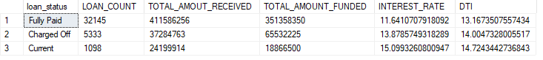

SELECT

loan_status,

SUM(total_payment) AS MTD_TOTAL_AMOUNT_RECEIVED,

SUM(loan_amount) AS MTD_TOTAL_FUNDED_AMOUNT

FROM

loan_data

WHERE

MONTH(issue_date) = 12

GROUP BY

loan_status

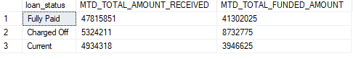

SELECT

loan_status,

SUM(total_payment) AS PMTD_TOTAL_AMOUNT_RECEIVED,

SUM(loan_amount) AS PMTD_TOTAL_FUNDED_AMOUNT

FROM

loan_data

WHERE

MONTH(issue_date) = 11

GROUP BY

loan_status

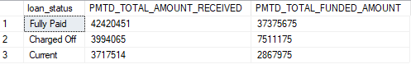

**Page 3: Charts**

**Monthly Trend by Issue Date**

SELECT

MONTH(issue_date) AS MONTH_NUMBER,

DATENAME(MONTH, issue_date) AS MONTH_NAME,

COUNT(id) AS TOTAL_LOAN_APPLICATIONS,

SUM(loan_amount) AS TOTAL_FUNDED_AMOUNT,

SUM(total_payment) AS TOTAL_RECEIVED_AMOUNT

FROM loan_data

GROUP BY MONTH(issue_date), DATENAME(MONTH, issue_date)

ORDER BY MONTH(issue_date)

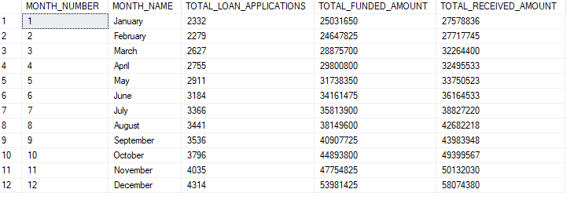

**Regional Analysis by State**

SELECT

address_state,

COUNT(id) AS TOTAL_LOAN_APPLICATIONS,

SUM(loan_amount) AS TOTAL_FUNDED_AMOUNT,

SUM(total_payment) AS TOTAL_RECEIVED_AMOUNT

FROM loan_data

GROUP BY address_state

ORDER BY SUM(loan_amount) DESC

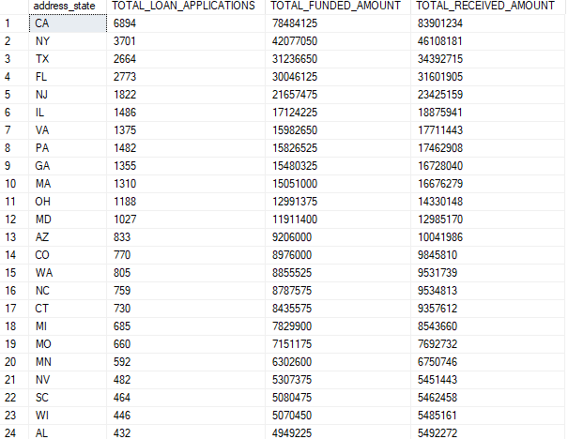

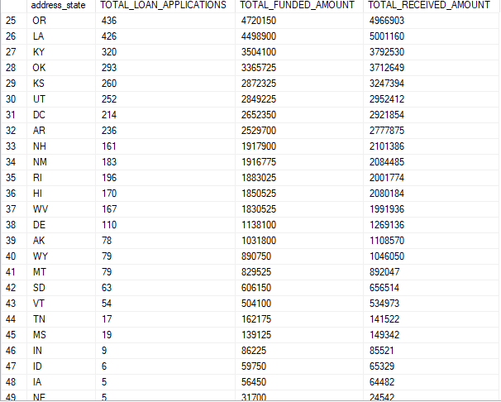

**Loan Term Analysis**

SELECT

term,

COUNT(id) AS TOTAL_LOAN_APPLICATIONS,

SUM(loan_amount) AS TOTAL_FUNDED_AMOUNT,

SUM(total_payment) AS TOTAL_RECEIVED_AMOUNT

FROM loan_data

GROUP BY term

ORDER BY term

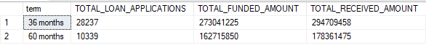

**Employee Length Analysis**

SELECT

emp_length,

COUNT(id) AS TOTAL_LOAN_APPLICATIONS,

SUM(loan_amount) AS TOTAL_FUNDED_AMOUNT,

SUM(total_payment) AS TOTAL_RECEIVED_AMOUNT

FROM loan_data

GROUP BY emp_length

ORDER BY COUNT(id) DESC

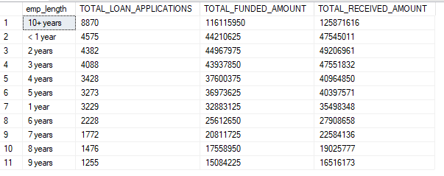

**Loan Purpose Breakdown**

SELECT

purpose,

COUNT(id) AS TOTAL_LOAN_APPLICATIONS,

SUM(loan_amount) AS TOTAL_FUNDED_AMOUNT,

SUM(total_payment) AS TOTAL_RECEIVED_AMOUNT

FROM loan_data

GROUP BY purpose

ORDER BY COUNT(id) DESC

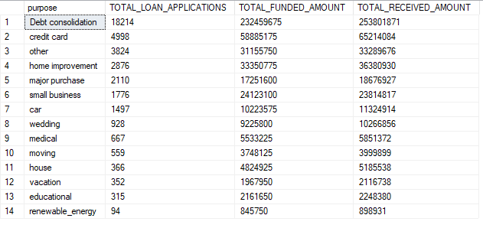

**Homeownership Analysis**

SELECT

home_ownership,

COUNT(id) AS TOTAL_LOAN_APPLICATIONS,

SUM(loan_amount) AS TOTAL_FUNDED_AMOUNT,

SUM(total_payment) AS TOTAL_RECEIVED_AMOUNT

FROM loan_data

GROUP BY home_ownership

ORDER BY COUNT(id) DESC

